Stage 3 STEAM Grid
Below you can find 25 STEAM activities which students can complete at home.
What is your favourite book? In this challenge, you will take your favourite children’s book and ANIMATE it! Use the program Scratch to create your animations. | Who doesn’t LOVE legos?! Grab a box of legos and just get to it! Build whatever pops into your imagination. Need some ideas?  -Lego community  -Lego ship  -Lego city  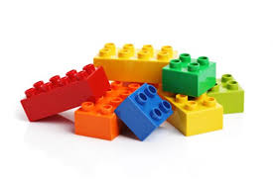 | Kindergartners learn the letters and their sounds so that they can begin reading. Your task is to create a video teaching the letters and their sounds! You can create a song, poem, or skit to do this. Go online to check out some alphabet sound songs so that you can get some ideas! Film your learning video and show it to a younger sibling or friend. | Do you enjoy making artwork out of paper? Have you ever tried origami? Follow the QR code to a free website that will teach you how to make origami! All you will need is some paper, an open mind, and some creativity! Get making! | Do you enjoy making or wearing jewellery? Your challenge is to sketch a design for a jewellery piece and make it using everyday items that can be found around your classroom or at home. Examples of items include: buttons, pipe cleaners, and ribbon.
The internet can be so fun! You can play games and chat with friends. The internet can also be unsafe. Design a laptop that opens and closes. On the screen create tips that help kids stay safe while online.  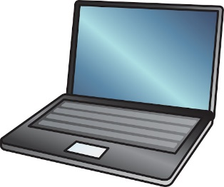 | Build a large maze using sticks! It must allow a mini plastic figure move through the maze from start to finish.  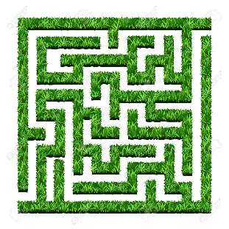 | Get your thinking cap on! Your challenge is to build the tallest structure possible using ONLY 50 plastic straws and a small roll of clear tape! Your structure must be able to support a tennis ball!  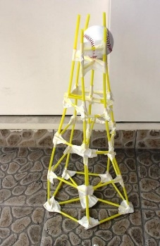 | Have you ever wanted to listen to music, but your iPhone didn’t play the music loud enough? Well, you get a chance to solve this problem! Using a paper towel tube and two paper cups, you will create an iPhone speaker. Try to figure out how to build this on your own, but if you need a little help, follow the link!  https://www.thecrafttrain.com/diy-iphone-speaker/ | Are you interested in learning how to Code? Head on over to Code Academy to start learning how to code by playing games. What could be more fun than that??
People throw cardboard away every day! The thing is, you can make so many amazing things out of cardboard! Think of something that you would like to make using recycled pieces of cardboard. Sketch your design, explain the purpose of it, and then build it! Need an idea? Scan the QR code! | A lot of teachers today are “flipping” their classrooms. This means that instead of teaching a lesson IN class, students watch a video of the lesson at home and then come to class to do activities. Your challenge is to create a video for younger students explaining one of the following math concepts: 1. Adding single digit numbers 2. Subtracting single digit numbers 3. Multiplying single digit numbers | A lot of kids spend time playing video games or going on the computer when they get home from school. Your task is to create a board game that you and/or your friends and family can play on “board game night”! Need some inspiration? -Make a trivia board game -Mathematical operation board game -A board game based on a popular book -A board game based on luck (rolling a dice, etc.) | Do you enjoy playing computer games? Maybe it is time that you created your very own! Head on over to Scratch, a program created by the Massachusetts Institute of Technology, that will allow you to create your very own game AND teach you how to code in the process! | Who would you choose as Prime Minister if you could choose? Design a trading card about that person with facts and information about them. Create a moveable part that reveals information.
Use your skills to design a contraption to protect a raw egg during a high fall. Your goals is to get your raw egg safely to the ground without breaking or cracking.  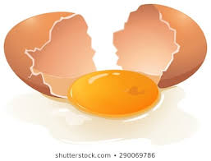 | Pick a famous landmark and recreate it out of Lego.  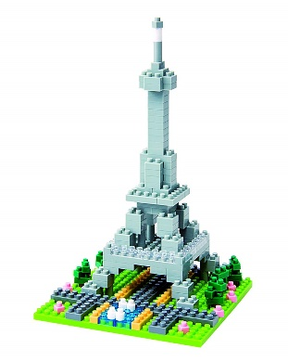 | Create a device that can help you draw a perfect circle. You must be able to draw 3 sizes. Use materials such as; straws, sticky tape, pencils and paddle pop sticks.  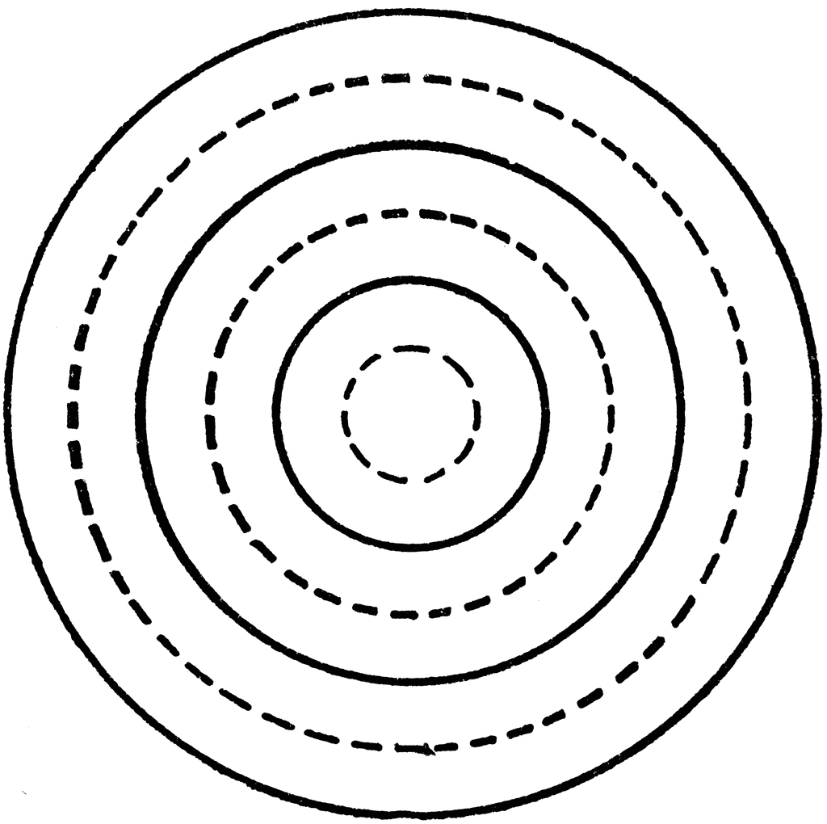 | Build a descending course for a marble run! The marble must roll down without assistance then roll onto the floor. You can use materials such as; newspaper, sticky tape, straws, paddle pop sticks etc.  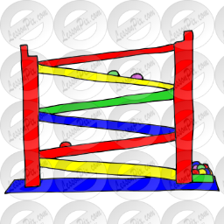 | Make a boat out of Lego that really floats in water!  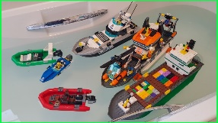
Duck tape is such a simple item, but you can do SO much with it! Think of something that you would like to make out of duck tape (a wallet, purse, outfit, etc.) Sketch your design, grab some duck tape, and go! Need some inspiration? Scan the QR code to get some great ideas! | You just took a great picture of your family but there is nowhere to put it! Build a frame that is sturdy and large enough to fit your picture. It must stand on it’s own. You can use cardboard scraps, scrap paper, pipe cleaners and paddle pop sticks.  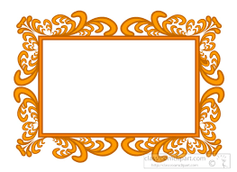 | Some artists make treasure, sculptures and artworks out of trash. Have a go at using some recycled materials to create an artwork or piece of treasure. Use materials such as; plastic bottles, cardboard, pipe cleaners, aluminium foil, buttons and bottle tops etc. Follow the link for inspiration!  https://eco-age.com/news/making-art-plastic-waste  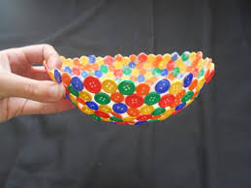 | This is an “upcycling” challenge! Use a soda bottle, plastic container, or wood, (if you have another idea that is OK just make sure it is waterproof) and any additional materials to create your very own working bird feeder! When you are finished hang your bird feeder outside of your school or house. If you need some inspirational ideas, follow the QR code. | For this Scratch project, you will create your very own animated presentation about Y-O-U! Create an animated version of yourself, your family, friends, pets, teachers, etc.! Some ideas for what to “talk about”: -Your family -Your favourites (colour, sports, music, moves) -Your hobbies -Memorable moments. Think of it as an “animated scrapbook!”

