Early Stage 1 STEAM Grid
Below you can find 25 STEAM activities which students can complete at home.
Write your favourite letters on the ground in chalk and then try and cover them with pebbles.  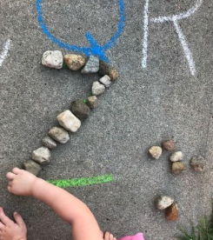 | What’s your favourite animal? Can you create a home or shelter for them out of lego?  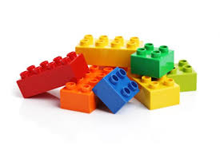 | Take some paper outside and try sketching a landscape. It might be of your house and garden or perhaps another view you might have from a verandah or patio. | Go outside and close your eyes and listen to all the sounds happening around you. Open your eyes and draw what you heard. | Make your own wrapping paper. Collect as many different leaves as you can and do some pencil/crayon rubbings.  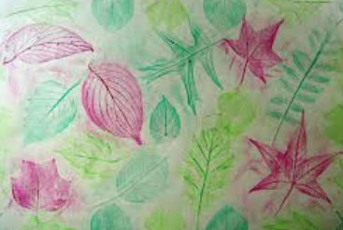
If you can borrow a phone or tablet and go outside and take photos of living things. Then try and draw what you have taken a photo of. | Build a large maze using sticks! It must allow a mini plastic figure move through the maze from start to finish.  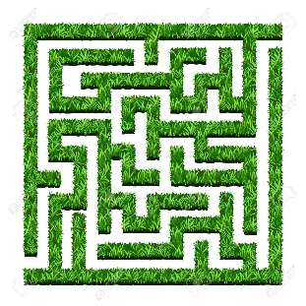 | Get your thinking cap on! Your challenge is to build the tallest structure possible using whatever recycled containers you have.  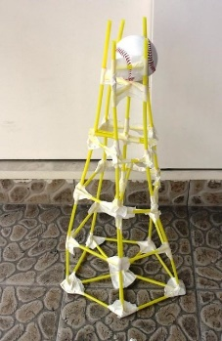 | Sit outside and look around you. What signs of life can you see? Birds, insects, flowers… Pick one and sketch it.  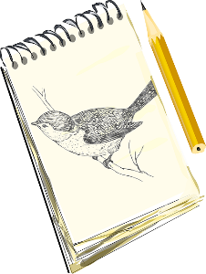 | Build a Lego bridge that can hold something heavy.  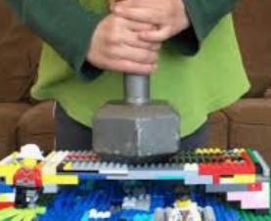
Make a boat out of Lego that really floats in water!  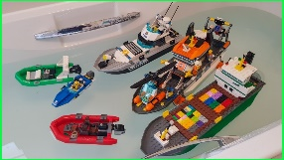 | Make shadow shapes on a wall or the ground and if you’re allowed trace them with chalk and then colour them in.  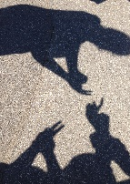 | Collect leaves and sticks and create a mural artwork with them.  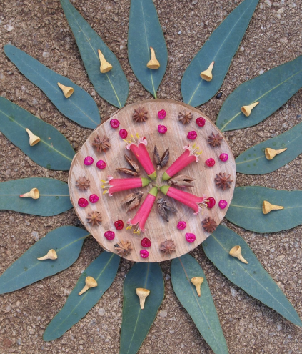 | Cement water painting. Design a mode of transport you’d like to travel on.  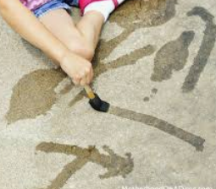 | Pretend you area a tracker. In the dirt create some animal tracks of a real or imaginary animal.  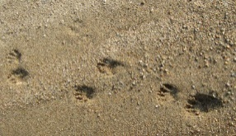
Think of something that you would like to make using recycled pieces of cardboard. Sketch your design, explain the purpose of it, and then build it!  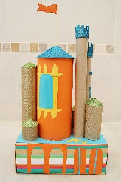 | Build a 50 brick tower. Challenge yourself with a 100 piece tower if you can.  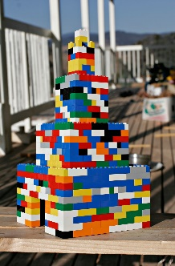 | Lie back and watch the clouds for a little while. Then sketch what you can in them. | Using only newspapers and sticky tape see if you can create a coffee table. It has to be strong enough to hold your favourite toy.  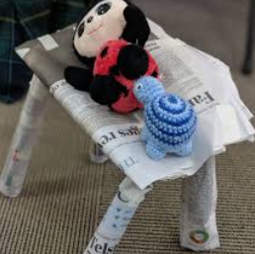 | Collect some gum leaves and see how creative you can be with creating an artwork from them.  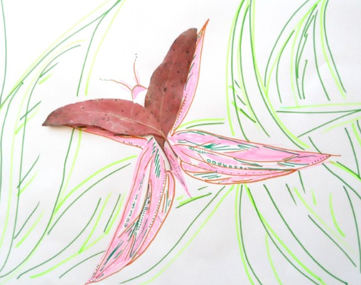
Do you have an older or younger sibling for who you could design a nature scavenger hunt?  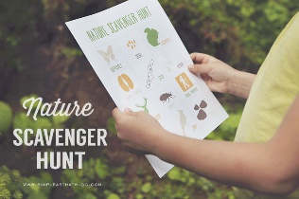 | You just took a great picture of your family but there is nowhere to put it! Build a frame that is sturdy and large enough to fit your picture. It must stand on it’s own. You can use cardboard scraps, scrap paper, pipe cleaners and paddle pop sticks. | Have a go at using some recycled materials to create an artwork or piece of treasure. Use materials such as plastic bottles, cardboard, pipe cleaners, aluminium foil, buttons and bottle tops etc. Follow the link for inspiration!  https://eco-age.com/news/making-art-plastic-waste  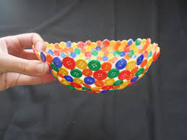 | Build something out of LEGO using only one hand.  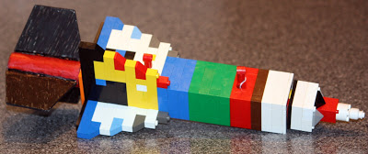 | Make a structure which you can fit completely inside and are then hidden from the outside world. Time yourself and see if you can make it again using different materials. Se if you can beat your time!  